*****P503/1***

***PHISICS***

*Paper 1*

*April 2024*

***TRINITY HIGH SCHOOL NYAKISI***

*Uganda certificate of education*

***END OF TERM ONE ASSESSMENT***

***S.3 PHYSICS***

***Paper 1***

*2 hours*

***INSTRUCTIONS:***

* Attempt only four items. All items carry equal marks.
* Items 1 and 2 are compulsory.
* Smartness and clear diagrams earns you more marks.

**Item one (1)**

Some bottles of colourless liquids were being labelled by the lab technician and accidentally mixed them up and lost a track of the content. 15.0cm3 of the sample of the liquid weighing 22.3g was withdrawn from one bottle which the technician suspect to be either acetone, benzene, chloroform or carbon tetrachloride.

He however has a challenge of identifying the right chemical so that he can label all the bottles correctly.

Support material:

|  |  |  |  |  |  |
| --- | --- | --- | --- | --- | --- |
| LIQUID | Acetone | Benzene | Chloroform | Water | Carbon tetrachloride |
| DENSITY (gcm3) | 0.792 | 0.899 | 1.487 | 1.000 | 1.595 |

Task:

1. What was the identity of the liquid? Clearly show your working.
2. With a reason which of the liquids shown in the table above can float on water? And identify the liquids on which water floats
3. Give any two practical applications of the knowledge of density.

**Item two (2)**

A newly recruited dentist was supposed to examine the tooth of the patient. The dentist wants to use a curved mirror of focal length 10cm but he is not so sure of the position of the patient’s from the mirror. The possible positions of the tooth from the mirror are A, B, C, D and E.

Support material;

|  |  |  |  |  |  |
| --- | --- | --- | --- | --- | --- |
| Position | A | B | C | D | E |
| Distance from the mirror. | 10cm | 5cm | 15cm | 20cm | 25cm |

Task:

1. Which type of the curved mirror is the dentist supposed to use?
2. As a physics learner, explain how you would help the dentist to select the best position of the patient’s tooth and give a reason why you have not selected the other positions.
3. Draw a ray diagram to illustrate the image of the tooth in the mirror when the tooth is at a position you have selected in (b) above and give atleast two features of image formed.

**Item three (3)**

The head teacher of a certain school of has just bought posho for students to eat which is claimed to be containing some small metallic particles which can be deadly to student’s lives.

He is confused about what to do with the posho and has already spent the school’s money to buy it and cannot return it to the shop.

Support material:

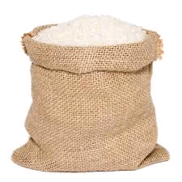 

The school has got a long insulated copper wire, switch, a 6-inch iron nail, connecting wires, a battery and iron fillings. The head teacher is advised by the food prefect to call you to come and give a help.

Task:

1. As a s.3 physics learner, help the head teacher on how he can use the available materials to design a prototype simple device that can be used to sort the impurities from the flour.
2. Suggest the precautions that must be taken while designing and using the device.
3. Give any two methods of magnetization and demagnetization.

**Item four (4)**

A certain company is packing sugar in packets for sell equal to m kg each packet, which is to be transported to the wholesalers using a bus. At the transportation point, peter observed that the bus was being loaded in the boot and not at the roof rack. John a wholesaler man has received complaints from the customers that he is selling to them sugar that is not equal to the branded amount which has caused him to lose more customers every day.

Support material:

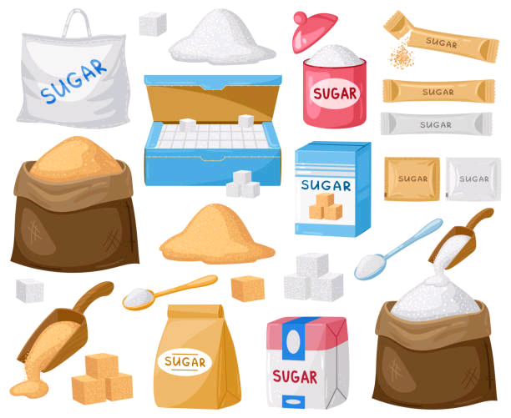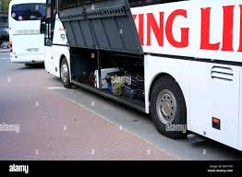

John in his shop has a mass of 2kg, a knife edge, a strong metre rule of mass 0.3kg, and a strong thread.

Task:

1. Help john and prepare for him a massage on how he can use the available materials in his shop to verify the amount of packed sugar which the company sells to him.
2. Given that john pivoted a metre rule at 60cm which balanced horizontally when a 2kg mass is at 30cm and a packet of sugar at 90cm mark. The branded (marked) value of sugar is 4kg. Verify if the customers’ complaint was true or false. what should john do with the sugar.
3. Explain peter’s observation.

**Item five (5)**

Moses and James were invited to attend a meeting which was to be conducted during the day and at night was a party. As they were travelling on a tarmac road in min-bus they observed a pool of water ahead but on reaching at that point the pool of water was not there and thought it was magic. The meeting was conducted on a projector and Moses sat in front but could not see clearly thus shifted and sat behind where he saw everything clearly. Moses had put on a red T-shirt with blue spots while James was in a yellow T- shirt with green strips.

In the room there was two bulbs A, which gives off white light and B, which gives off a green light. When the meeting ended, late evening the party started with bulb A on and B off. Later the music started with bulb A switched off and B turned on and the T-shirts for Moses and James changed the colours.

Task:  
(a) Explain the pool of water observed by the two boys in their way.

(b) Which eye defect is Moses suffering from and explain using a ray diagram how it can be solved.

(c) What colour(s) did the T-shirts of Moses and James turn to when bulb B was switched on? Explain your answer.

(d) Give two similarities between a human eye and a lens camera.

***END***